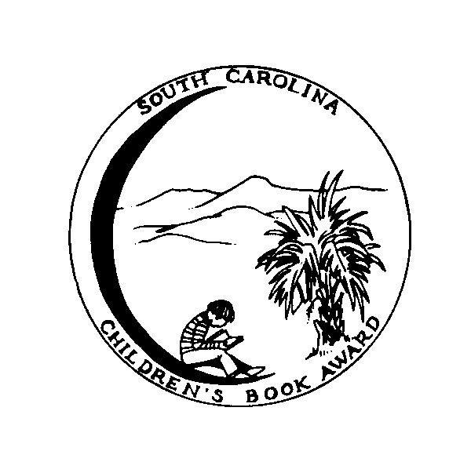
2009/2010 Children’s Book Award Nominees

Attack of the Turtle
Drew Carlson
The Aurora County All-Stars
Deborah Wiles
Brendan Buckley’s Universe and
Everything in It
Sundee Tucker Frazier
The Castle Corona
Sharon Creech
Dragon’s Egg
Sarah L. Thomson
Eleven
Patricia Reilly Giff
Emma-Jean Lazarus Fell Out of a
Tree
Lauren Tarshis
A Friendship for Today
Patricia McKissack
Lawn Boy
Gary Paulsen
Leepike Ridge*
Nathan D. Wilson
The Lemonade War
Jacqueline Davies
Me and the Pumpkin Queen
Marlane Kennedy
The Mysterious Benedict Society
Trenton Lee Stewart
The Mysterious Case of the
Allbright Academy
Diane Stanley
No Talking
Andrew Clements
On the Wings of Heroes
Richard Peck
Paint the Wind
Pam Munoz Ryan
Rickshaw Girl
Mitali Perkins
Swindle
Gordon Korman
Two-Minute Drill
Mike Lupica

